**Vex Change-Up: 2020-2021 Robotics Season Strategy Notebook**

*Match Field Top View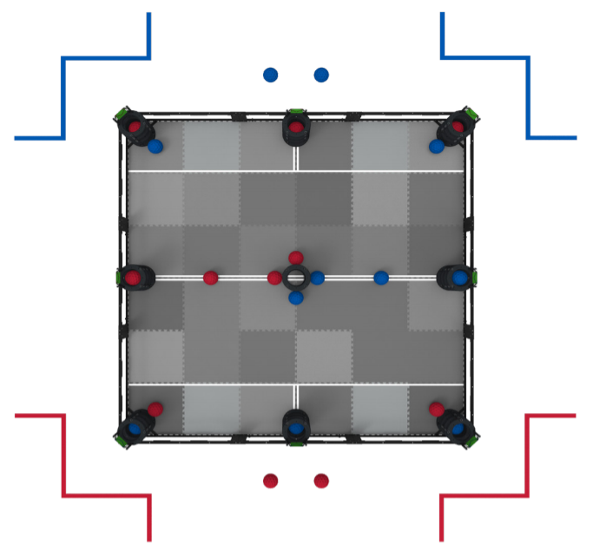

**Table of Contents:**

Initial Impressions ------------

Leading to ASIJ ---------------

General Strategies -----------

Offensive Strat (Point scoring) --------

Defensive Strat (Preventing Points) ---